AD23532 – PRINCIPLES OF DATA SCIENCE
EXP 1: Data Preprocessing and Cleaning – Telco Customer Churn
Question:
A telecommunications company is experiencing customer churn. Preprocess the Telco Customer Churn dataset by handling missing values, removing duplicates, encoding categorical features, standardizing numerical attributes, and visualizing important relationships.

AIM:
To perform data preprocessing and cleaning on the Telco Customer Churn dataset by removing duplicates, handling missing values, encoding categorical variables, standardizing numerical features, and visualizing data distributions and correlations.

ALGORITHM:
- Import the required Python libraries: Pandas, NumPy, Matplotlib, Seaborn, and Scikit-learn.
- Load the dataset into a Pandas DataFrame and display the first 10 records, last 10 records, shape, and column names.
- Explore the dataset using info(), describe(), and check missing values and duplicate records.
- Remove duplicate records and replace missing numerical values with the median and categorical values with the mode.
- Encode categorical columns using Label Encoding and One-Hot Encoding.
- Standardize Tenure, MonthlyCharges, and TotalCharges using StandardScaler.
- Plot the distributions of MonthlyCharges and Tenure, and create a count plot of Contract versus Churn.
- Draw a box plot of MonthlyCharges grouped by Churn and display the correlation heatmap of numerical features.

PROGRAM & OUTPUT:

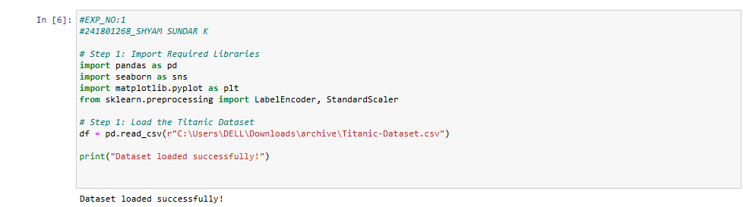
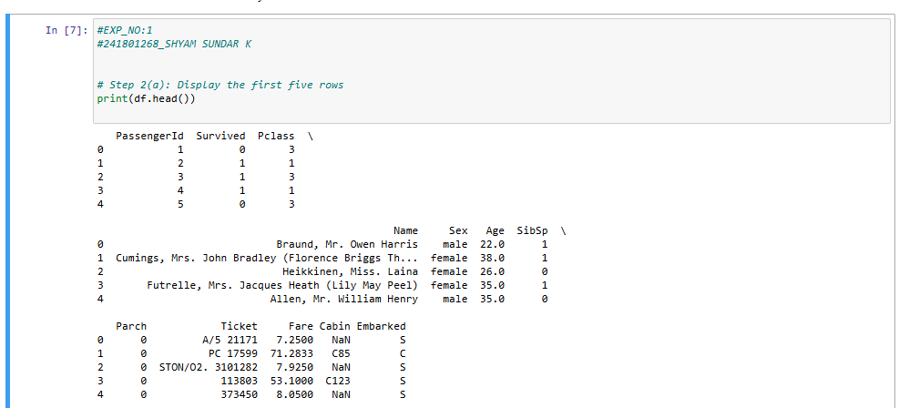
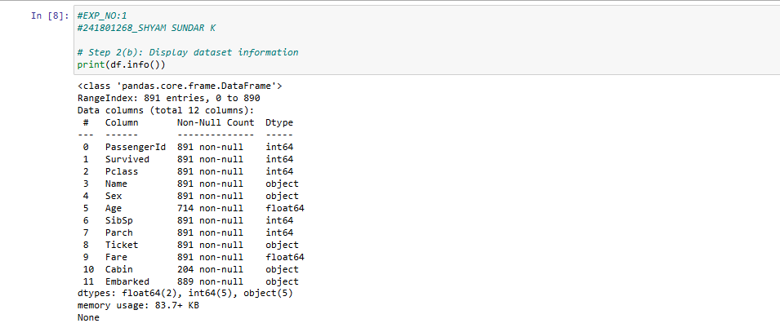
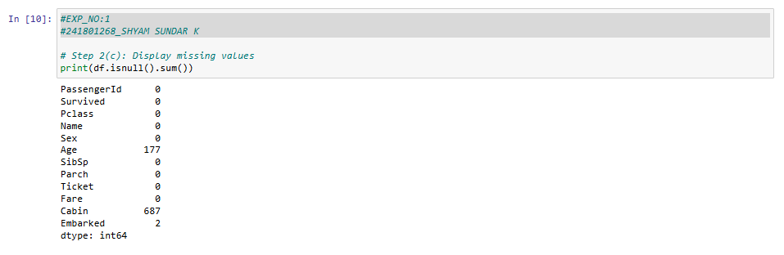
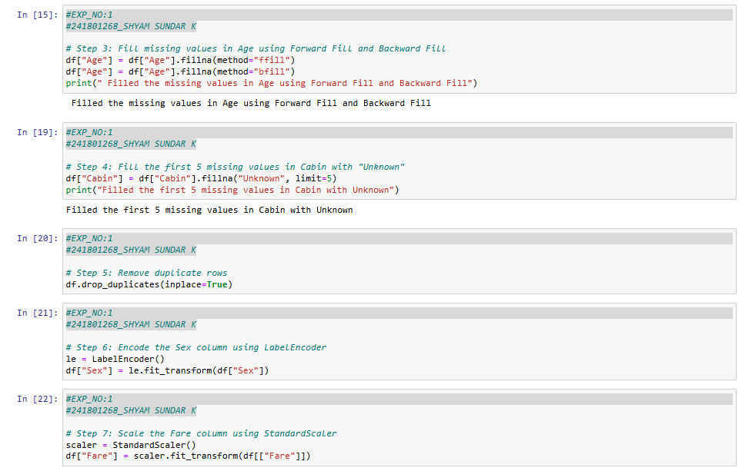

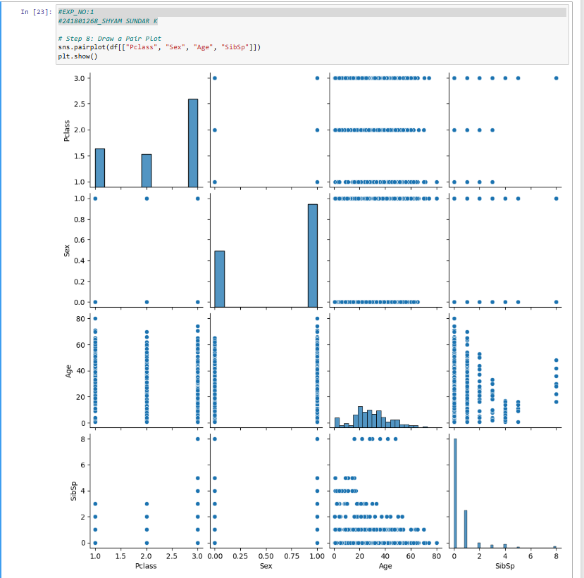
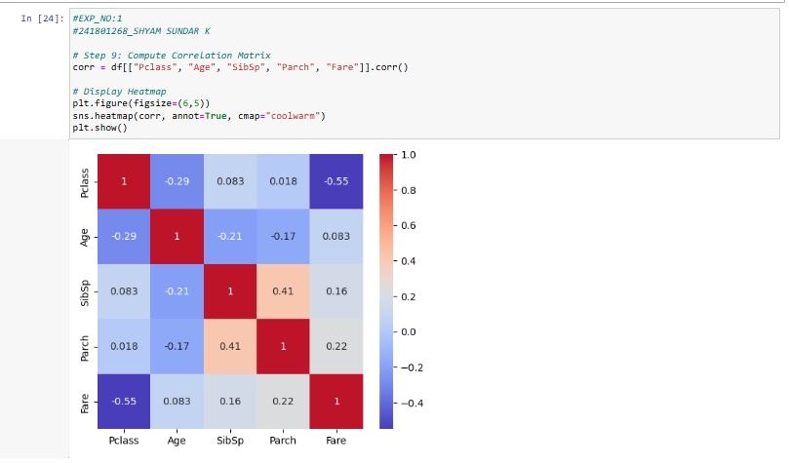

RESULT:
Thus, the Telco Customer Churn dataset was preprocessed successfully by removing duplicate records, handling missing values, encoding categorical variables, and standardizing numerical features. The distributions of Monthly Charges and Tenure, Contract versus Churn count plot, box plot of Monthly Charges grouped by Churn, and correlation heatmap were generated to visualize and understand the dataset.

